Name__________________________________________________Date________Period____

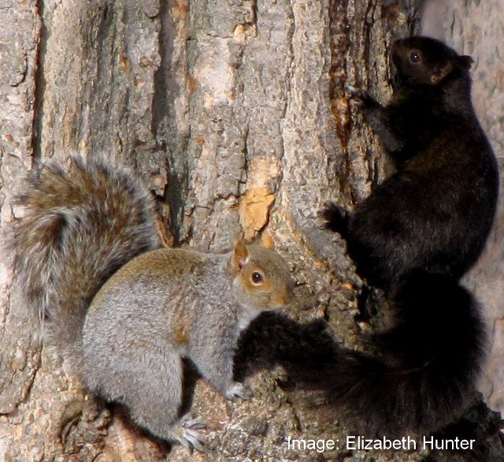
Title: Evolutionary Advantage of The Eastern Gray Squirrel
Beth Krauss and Maureen Collier

Introduction
Eastern gray squirrels (Sciurus carolinensis) are common in both urban areas and rural forests throughout the species' native range in the United States and Canada, and in parts of Europe and Africa where they are introduced. They occur in three color morphs.

Range
The gray squirrel is native to the eastern and midwestern United States and the southern portions of Canada. Although the black morph was abundant in rural woodlands before the 19th century, it is now most plentiful in cities. Additionally gray squirrels have been introduced in California, Montana, Oregon, and Washington in the USA, and Quebec, New Brunswick, British Columbia, Manitoba, Nova Scotia, Ontario, and Saskatchewan in Canada. They have also been introduced in South Africa and Europe.

Human Induced Environmental Change
Settlement of North American dramatically changed the landscape; especially in the gray squirrel's native range, where many of the permanent settlements were first established and black morph squirrels declined. The landscape was mainly forested prior to settlement, experiencing small-scale disturbances by native people (e.g., clearing, burning). European colonists began clearing forests in the 1600s, and deforestation peaked in the early 1800s as forests were converted to farms to support growing urban populations. The advent of agricultural markets and more productive soils in the midwestern U.S. led to abandonment of farms and regrowth of forests in the eastern U.S. beginning in the 1850. In the northeastern U.S. today, for example, only 0.2% of forests are considered "old growth" (i.e., never harvested by people) compared to >70% prior to settlement. Similar patterns of forest change occurred in the upper midwestern U.S. and southeastern Canada where the black morph squirrel was historically common.
Urban squirrels face other artificial constructs today. Modern cities introduce artificial stressors (e.g., pollution, infrastructure, temperature moderation). Vehicular collisions, a source of direct mortality, appears to be the primary mortality agent for urban squirrels. Additionally, bird feeders and trash are a source of easily obtained food.

Genetics
Coat color in gray squirrels is found in three morph types, the wild-type, gray, black and a brown black. Inheritance is through a simple Mendelian trait which includes incomplete dominance. The wild-type gray morph is homozygous recessive, the black melanistic morph is homozygous dominant and the brown-black morph is heterozygous. The melanocortin 1 receptor (MC1R) gene provides instructions for making a protein called the melanocortin 1 receptor. This receptor plays an important role in normal fur pigmentation. The receptor is primarily located on the surface of melanocytes, which are specialized cells that produce a pigment called melanin. There is a 24-bp deletion that distinguishes the gray morph from the black morph.

Crypsis
Pelt color can affect fitness in many different ways with camouflage from predators being a direct selective mechanism with large effects on survival. Old-growth forests have structural features that may have provided greater concealment to black morph than gray individuals, including heavier canopy cover that creates deep patches of shade and the presence of coniferous trees with dark foliage. The gray morph may be more concealed in secondary forests that consist of even- aged stands with little canopy cover. It has been hypothesized that the shift from old growth to secondary (regrown) forests in rural areas changed how gray and melanic morphs are concealed from predators, including humans (hunters). Squirrels have a variety of avian and mammalian predators and have been hunted by people for centuries. The decline of the black morph squirrels began in the late 1800s as forests regenerated and squirrels were heavily hunted. Hunting pressure remains intense; there are >1.5 million squirrel hunters in the U.S.

Thermogenesis
In winter melanic black squirrels have lower heat losses and lower basal metabolic rates when compared to the gray morph at temperatures between -20 and 25^{O}C. This lower deep body temperature, metabolic rate and thermal conductance during the winter months may be beneficial in cold, food scarce, deciduous, and mixed forests. In contrast gray morphs who live in more southern, food rich environments with their higher basal metabolic rate may have an advantage in the collections and use of stored and available food resources.

Your Task
Working in your lab group, generate a claim as to the evolutionary adaptive advantage of coat color in the Eastern Gray Squirrel in a particular environment. Use the resources presented in SquirrelMapper to gather your data. There are many good additional resources for the two squirrel morphs https://en.wikipedia.org/wiki/Black_squirrel https://en.wikipedia.org/wiki/Eastern_gray_squirrel. Your teacher can also suggest additional readings.

The guiding question for this investigation: Is there an evolutionary selective/adaptive advantage for one squirrel color morph in a particular environment?

Materials
You will use any of the following programs and websites.
Squirrel mapper https://squirrelmapper.org/map.html
Information on the Eastern gray squirrel https://en.wikipedia.org/wiki/Eastern_gray_squirrel
Information on the black morph https://en.wikipedia.org/wiki/Black_squirrel

Getting Started
Using SquirrelMapper you will explore the data that is available to you and the comparisons that can be made. See the appendix for a tutorial on Squirrel Mapper.

From this exploration you will choose the environment you will use to answer the guiding question. You may want to learn more about gray squirrels; you can use the resources listed in materials or find other resources to use.

Think about what type of data you will need to collect and how it will be recorded.
You may be required to complete a statistical analysis, what test(s) would that be and what is that data. See the document and spreadsheet on Chi Square analysis to calculate the expected values.

Argumentation Session
After gathering and analyzing your data your group will prepare a white board/poster where you can share your initial argument with other groups. This will be done using a round robin format. Groups will give constructive feedback. and revise your initial argument.

Argument Presentation Template
The Guiding Question:
Our Claim:
Our Evidence: | Our Justification of the Evidence:

APPENDIX I
Instructions to compare urban-rural morph proportions with a Chi-squared contingency analysis with a single sample

Getting the data

- Navigate to SquirrelMapper
- Select an area. For this tutorial I will select Syracuse, NY under “Choose a Story”.
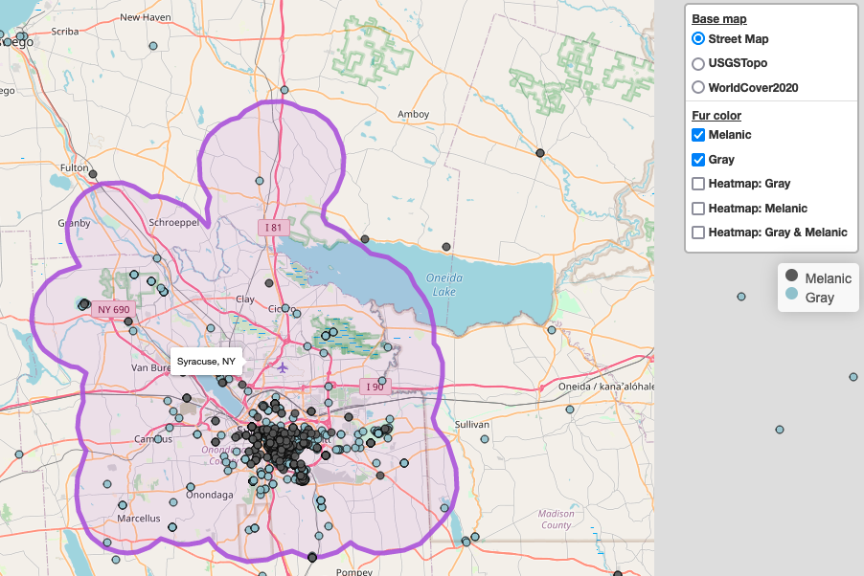

- Scroll to the bottom of the page and select “Morph totals by urban land use” to see the breakdown of melanic and gray squirrels by urban and rural land use categories. The sample sizes are reported on the top of the bars on the chart:

- Make a contingency table of the “observed” data in a spreadsheet. I’ll use this example spreadsheet.

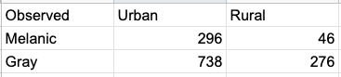

Conducting the contingency analysis
- State the statistical hypotheses.
  - Null hypothesis (H₀): Morph proportions are independent of land use (urban vs. rural).
  - Alternative hypothesis (H_{A}): Morph proportions differ between urban and rural land use.

- Use the observed data in the contingency table to quantify expected proportions of each coat color in urban and rural environments.
  - Calculate the proportion of melanic and gray squirrels overall:
    - Melanic: (296 + 46) / (296 + 46 + 738 + 276) = 0.25
    - Gray: (738 + 276) / (296 + 46 + 738 + 276) = 0.75
  - Calculate the proportion of urban and rural squirrels overall:
    - Urban: (296 + 738) / (296 + 46 + 738 + 276) = 0.76
    - Rural: (46 + 276) / (296 + 46 + 738 + 276) = 0.24
  - Use the multiplicative probability rule to quantify the expected probabilities of each coat color in urban and rural environments. The key here is that the multiplicative rule assumes that coat color and land use are independent, so these probabilities provide the expected data for the null hypothesis.
    - P(melanic and urban) = 0.25 * 0.76 = 0.19
    - P(gray and urban) = 0.75 * 0.76 = 0.57
    - P(melanic and rural) = 0.25 * 0.24 = 0.06
    - P(gray and rural) = 0.75 * 0.24 = 0.18

- Chi-squared analyses are done on counts of individuals, not proportions (i.e., probabilities, so you have to convert your expected probabilities to expected counts. Simply multiply each probability by the total sample size of squirrels (296 + 46 + 738 + 276 = 1356). The values will have decimals. That’s OK because these are the expectations on average.
  - Expected melanic and urban = 0.19 * 1356 = 260.8
  - Expected gray and urban = 0.57 * 1356 = 773.2
  - Expected melanic and rural = 0.06 * 1356 = 81.2
  - Expected gray and rural = 0.18 * 1356 = 240.8

- Calculate the Chi-squared test statistic and P-value.
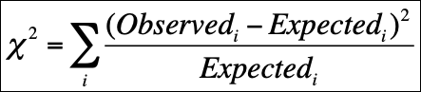
  - X² = (296 - 260.8)2/260.8 + (738-773.2)2/773.2 + (46-81.2)2/81.2 + (276-240.8)2/240.8 = 26.78.
  - The degrees of freedom for a contingency analysis with two categories for both variables is 1.
  - The P-value is quantified with spreadsheet software using the =CHISQ.DIST.RT function. In this case the P-value is 0.0000002, far below the typical significance value of 0.05.

- Interpret
  - If the P-value is lower than the significance value of 0.05, we usually reject the null hypothesis. In this case the P-value is VERY low (P<0.001), so we conclude that morph proportions do vary between urban and rural land use categories.
  - Conclusion statement: The probability of melanic squirrels was greater in urban than rural land use (X² = 26.8, df = 1, P < 0.001).
  - The figure reported on SquirrelMapper shows the observed probabilities of each morph by land use category, supporting the analysis here.
  - Note that the SquirrelMapper app reports a Fisher’s Exact Test, which is a slightly different type of test but is used for the same purpose of comparing morph proportions between land use categories. The conclusion from the contingency analysis and exact test will usually be the same.

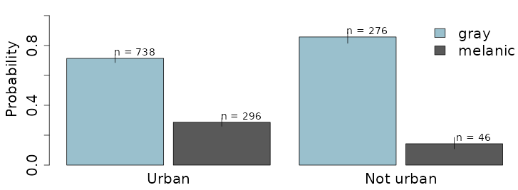
APPENDIX II
Squirrel Mapper Tutorial

Squirrel Mapper allows the user to gather data on the Eastern Gray Squirrel coat color morphs. Follow these directions to gather data.
- Using the +/- button or a mouse, increase the map size until the region you are interested in is at an appropriate scale.
- You can change the map base and the fur color that will be represented on the map. Your choices will depend on the type of data you are looking for.

- Now you are ready to gather your data. Click on “Select an Area” and you have two choices. Name your selection set which gives you the ability to draw a boundary around the area you want data from or Example Stories that have predetermined boundaries around various cities. Select Submit.

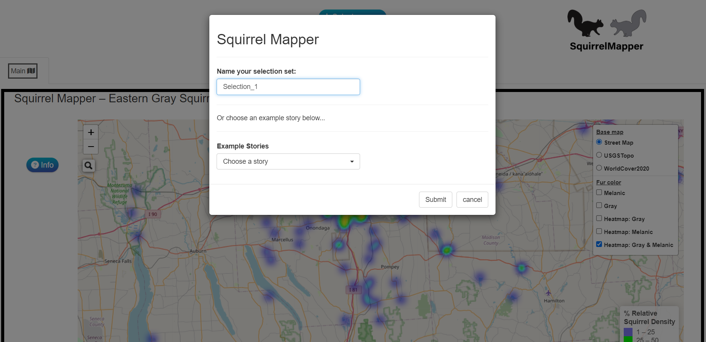

- Once you enter a name for the area you want to investigate and click submit, a yellow hexagon box will appear on the left hand side. Follow the directions on the screen to draw your outline.

- Various data options will appear at the button of the map. To retrieve the data that you will need click on the “data” tab and download the CSV file with 500 entries.

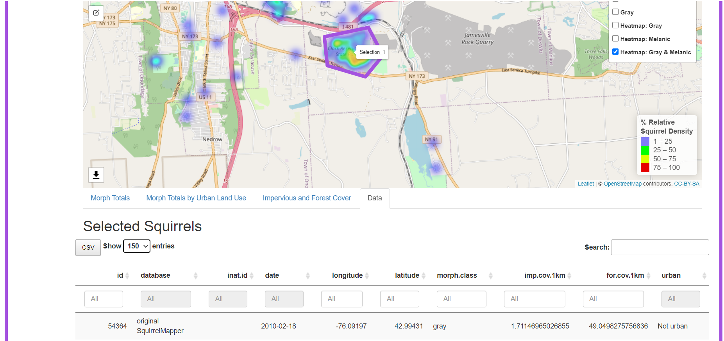

Name
Science Explanation (CER) Student Rubric
4 (Strong) 3 (Good) 2 (Fair) 1 (Weak) 0 (missing)
Claim (Thesis or Topic Sentence) | • The claim clearly and correctly answers the question.  • Claim does not include an explanation. | • The claim correctly answers the question but is not clear.  • The claim includes a brief explanation. | • The claim is not completely correct.  • The claim includes a lengthy explanation. | • The claim is incorrect or unclear.  • The claim seems to ramble on. | No Claim
Evidence | • All evidence is relevant data or observations from an experiment or scientific investigation.  • Experiment is briefly described to provide context.  • Multiple pieces of evidence are used to back up the claim.  • All data are specific and accurate. | • Most evidence is relevant data or observations from an experiment or scientific investigation.  • Experiment is described, but in too much detail.  • One piece of additional evidence is needed to back up the claim.  • Data are accurate but not specific. | • Some evidence is relevant data or observations from an experiment or scientific investigation.  • Experiment is briefly described, but not in enough detail.  • More pieces of evidence are needed to back up the claim.  • Data are specific but not accurate. | • Evidence is not relevant data or observations from an experiment or scientific investigation or not relevant.  • Experiment is not described.  • Many more pieces of evidence are needed to back up the claim.  • Data are neither specific nor accurate. | No Evidence
Reasoning (Analysis) | • Explicit reasoning is provided that links all evidence to the claim.  • Scientific principles are correctly explained to show how and why the evidence supports the claim.  • The claim is clearly referenced throughout the reasoning. | • Reasoning links most pieces of evidence to the claim.  • Scientific principles are correctly explained but need more detail.  • The claim is referenced, but not throughout the reasoning. | • Reasoning links some evidence to the claim.  • Scientific principles are explained but slightly incorrect.  • The claim is referenced, but not clearly. | • Reasoning is weak and does not make a connection between the evidence and the claim.  • Scientific principles are not explained or explained incorrectly.  • The claim is not referenced. | No Reasoning
Overall | • All parts of the prompt are answered.  • Science vocabulary words are used appropriately and correctly.  • Appropriate Science tone (impersonal passive tone).  • The organization of the response is logical (claim comes first, then evidence and reasoning).  • Uses transitions to improve the flow of the writing.  • There are no spelling, grammar, or punctuation issues that hinder meaning. | • Most parts of the prompt are answered.  • Science vocabulary words are used, but slightly incorrectly.  • Tone is mostly scientific.  • The order of the response is mostly logical.  • Uses some transitions to improve the flow of the writing.  • The paragraph is mostly free of spelling, grammar, and punctuation problems. | • Some parts of the prompt are answered.  • Few science vocabulary words are used correctly.  • Tone is scientific except for pronouns like “we,” “you,” or “I.”  • The order of the response is somewhat logical.  • Uses few transitions to improve the flow of the writing.  • The paragraph has several spelling, grammar, and punctuation problems. | • Little of the prompt is answered.  • Science vocabulary words are not used or are used incorrectly.  • Tone is unscientific.  • The order of the response is not logical.  • The flow of the writing is choppy and needs transitions.  • Spelling and punctuation problems make it challenging to understand the paragraph. | The prompt is not answered.  It is impossible to understand the response.

