Squirrel Mapper Tutorial

Squirrel Mapper allows the user to gather data on the Eastern Gray Squirrel coat color morphs. Follow these directions to gather data.
- Using the +/- button or a mouse, increase the map size until the region you are interested in is at an appropriate scale.
- You can change the map base and the fur color that will be represented on the map. Your choices will depend on the type of data you are looking for.

- Now you are ready to gather your data. Click on “Select an Area” and you have two choices. Name your selection set which gives you the ability to draw a boundary around the area you want data from or Example Stories that have predetermined boundaries around various cities. Select Submit.

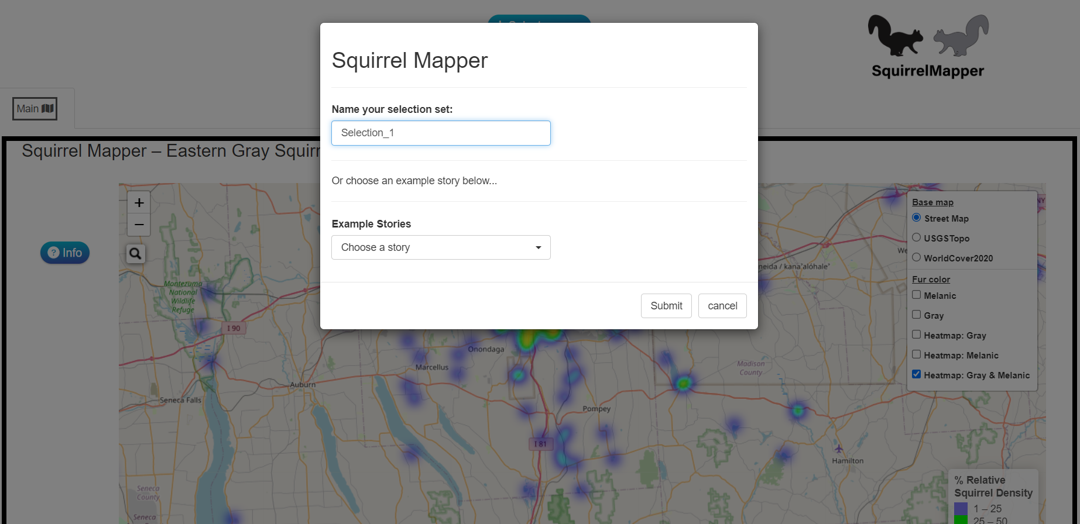

- Once you enter a name for the area you want to investigate and click submit, a yellow hexagon box will appear on the left hand side. Follow the directions the screen to draw your outline.

- Various data options will appear at the button of the map. To retrieve the data that you will need click on the “data” tab and download the CSV file with 500 entries.

