Name: __________________________________ Date: ___________________ Period: _________________________________
Squirrels Here, There and Everywhere!
Habitat
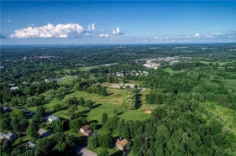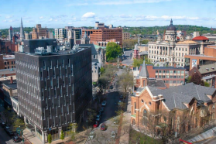Rural Pompey Urban Syracuse
The average yearly temperature of Pompey is 46.04°F The average yearly temperature of Syracuse is 46.30°F The average yearly precipitation of Pompey is 40.22 inches The average yearly precipitation of Syracuse is 39.80 inches The average yearly snowfall of Pompey is 82.97 inches The average yearly snowfall of Syracuse is is 93.52 inches
Directions: Make observations of the rural and urban environments above!
Rural Pompey Urban Syracuse

1
Directions: Read the following article and define biotic and abiotic!
In ecology, biotic and abiotic factors encompass all the living and non-living parts of an ecosystem. Biotic factors pertain to living organisms and their relationships. Abiotic factors are the non-living components of the ecosystem, including sunlight, water, temperature, wind, and nutrients.
Ecologists use biotic and abiotic factors to predict population changes and ecological events. By investigating how these factors interact, ecologists can gauge what is happening in an ecosystem over time. They may also be able to predict ecological events like species die-offs, over-population, changes in growth rates, and disease outbreaks.
Biotic Factors
Biotic factors include interactions between organisms, like disease, predation, parasitism, and competition among species or within a single species. In addition, living organisms themselves are biotic factors. They fall into three main categories: producers, consumers, and decomposers.
Abiotic Factors
Abiotic factors are the non-living components of the ecosystem, including its chemical and physical factors. Abiotic factors influence other abiotic factors. In addition, they have profound impacts on the variety and abundance of life in an ecosystem, whether on land or in water. Without abiotic factors, living organisms wouldn’t be able to eat, grow, and reproduce. Below is a list of some of the most significant abiotic factors: sunlight, oxygen, temperature, wind, water, ocean currents and nutrients
Define biotic: ____________________________________________________________________________________________________________________________ ____________________________________________________________________________________________________________________________________
Define abiotic: ___________________________________________________________________________________________________________________________ ____________________________________________________________________________________________________________________________________
Directions: Classify the observations you made for rural and urban environments above as either abiotic or biotic.
Rural Pompey Urban Syracuse
Biotic | Abiotic Biotic | Abiotic

2
Getting to know the squirrels
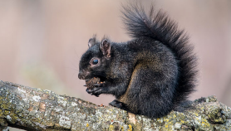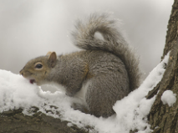Sciurus carolinensis
Directions: Make observations of the physical characteristics of the black and gray squirrels. Then list characteristics that both black and gray squirrels have in common in the middle column!
Black Squirrel Characteristics Both Black and Gray Squirrel | Gray Squirrel Characteristics

Where are the squirrels
Getting to know Squirrel Mapper
1. Go to https://squirrelmapper.org/index.html
2. Under “Explore Research on Evolution” click on the box all the way to the left, labeled “Interactive Squirrel Map” 3. Read top paragraph on how the map was build
4. Click on the map to explore SquirrelMapper
5. Work with SquirrelMapper a little to get use to the tools and how to use it
a. Click and hold as a the little hand to move the map around and center in on a different area b. In white box on the right, the base map can be changed to street view, USGS Topo (land surfaces) and WorldCover 2020 (plant coverage)
c. Under fur color, click melanic (black fur) and gray to show circles of the locations of the recorded gray squirrels and black squirrels
d. Up above the map, click on “+select an area” you can name the selection and click submit. Click on the left side of the map a yellow box with a hexagon. Then trace the area you want to measure. Be sure to connect the end with the beginning.
6. Be sure to look at the data and graphs produced below the maps to get familiar with available data 3
Analyzing Data
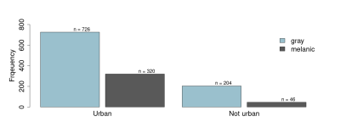
Data for urban and rural areas have been provided for you below. It was collected from squirrel mapper on March 13,2023. 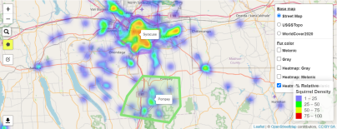
Urban Data: Syracuse Frequency of Morph
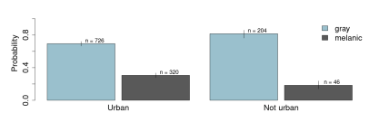
Urban Data: Syracuse Probability of Morph
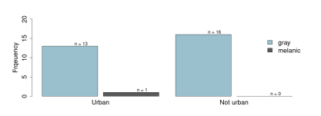
Rural Data: Pompey Frequency of Morph
Rural Data: Pompey 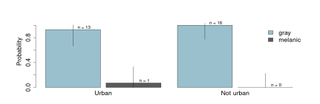Probability of morph 4
What patterns do you notice in the data on page four regarding the number of black versus gray squirrels found in Syracuse (urban) and Pompey (rural)?

How can biotic and abiotic factors explain the pattern that you noticed from the data of black versus gray squirrels ?

Population Maximums
Describe the population of gray squirrels over the
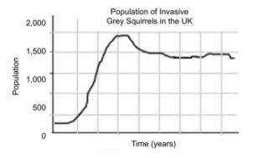time on the graph to the left. What do you think the estimated “limit” of gray squirrels is that the United Kingdom can support? And what is this called?
What do you think determines the population “limit” for a species in an ecosystem?

5
Squirrels Near and Far
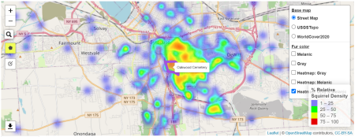
Oakwood Cemetery
(middle of map) is a
160 acre cemetery
within the city of
Syracuse that was
established in 1859.
It is a historic,
picturesque
landscape filled with
art and architecture
and monuments and
mausoleums.
Oakwood Cemetery: Frequency of Morph
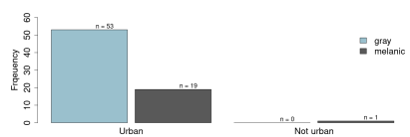
Oakwood Cemetery: Probability of morph
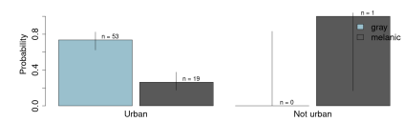
What observations can be made about the squirrel population in Oakwood cemetery compared to the Syracuse squirrel population on page 4?

Are the biotic and abiotic factors the same in each location? How does that impact the squirrel population? 6
Select one biotic or abiotic factor and determine how increasing or decreasing it would change the carrying capacity of the squirrel population.

Using the data from Oakwood Cemetery, create a graph of the
carrying capacity over time. Assume that this population of
squirrels is stable at their carrying capacity. Be sure to
include all necessary components of a graph.
In a different color, add an additional line to show how the
carrying capacity would change if your chosen biotic or
abiotic factor was increased or decreased.
Why would changing your chosen biotic or abiotic factor cause your predicted effect on the carrying capacity of the Oakwood Cemetery squirrel population?

What other effects could changing the squirrel population have on the Oakwood Cemetery ecosystem? 7
The map on the left shows the observations of squirrels collected from iNaturalists through August 2021. What patterns do you notice?

What inference can you make based on the pattern you observed?

Why do you think this pattern occurs? What biotic and abiotic factors influenced this pattern?

References
black squirrel - https://www.lifeinthefingerlakes.com/a-black-gray-squirrel/
grey squirrel - http://www.biokids.umich.edu/critters/Sciurus_carolinensis/
Oneida NY: https://www.landsearch.com/properties/409-genesee-st-oneida-ny-13421/2157967
Syracuse NY:https://uncoveringnewyork.com/things-to-do-in-syracuse-ny/
Biotic and Abiotic reading - https://www.treehugger.com/biotic-and-abiotic-factors-5116478
Carrying capacity graph - https://www.teacherspayteachers.com/Product/Carrying-Capacity-Inquiry-warm-up-5271968?st=c91c48009be2cbeaa2dff70dde992225
Squirrel Graph - https://www.bartleby.com/questions-and-answers/a.-what-is-the-carrying-capacity-of-this-grey-squirrel-population-b.-grey-squirrels-are-invasice-spe/aaa6c660-bc3b-434d-938b-51642eefbb73 Weather - http://www.usa.com/pompey-ny-weather.htm
Oakwood - https://oakwoodofsyracuse.com/our-history/
8

